注意事项

文档中有两种颜色的标注

红色标注：提示敏感信息（没有写出来）需要进行实际替换

蓝色标注：提示注意接口参数，已发生变化

接口测试

### 1.删除 database

http://localhost:8081/proxy-server/ddlOrInsert?isHiveTable=false&sql=drop database if exists hive.test_demo_db CASCADE

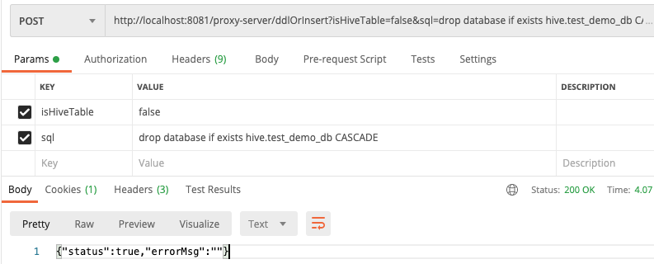

### 2.创建 database

http://localhost:8081/proxy-server/ddlOrInsert?isHiveTable=false&sql=create database if not exists hive.test_demo_db

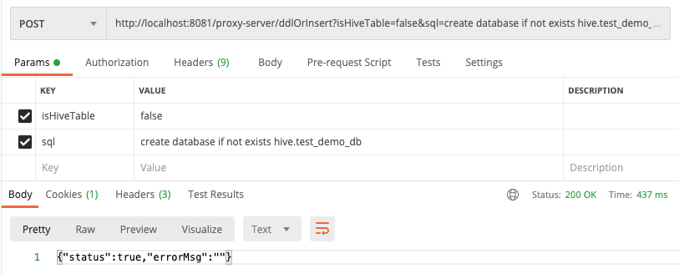

### 3.删除 TIDB 映射表

http://localhost:8081/proxy-server/ddlOrInsert?isHiveTable=false&sql=drop table if exists hive.test_demo_db.tidb_stu

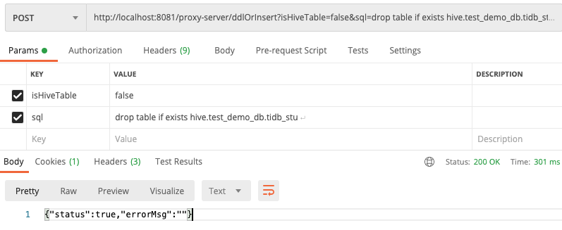

### 4.创建 TIDB 映射表

**分别创建两种 TIDB 映射表：**

http://localhost:8081/proxy-server/ddlOrInsert?isHiveTable=false&sql=CREATE TABLE hive.test_demo_db.**tidb_stu_details**(id int,name string,city string) WITH ('connector' = 'tidb','tidb.database.url' = 'jdbc:mysql://${IP}:${PORT}/flink','tidb.username' = 'makoto','tidb.password' = '123456','tidb.database.name' = 'hack_test','tidb.maximum.pool.size' = '10','tidb.minimum.idle.size' = '0','tidb.table.name' = **'tidb_stu_details'**,'tidb.write_mode' = 'upsert','sink.buffer-flush.max-rows' = '0')

http://localhost:8081/proxy-server/ddlOrInsert?isHiveTable=false&sql=CREATE TABLE hive.test_demo_db.**tidb_stu**(id int,name string) WITH ('connector' = 'tidb','tidb.database.url' = 'jdbc:mysql://${IP}:${PORT}/flink ','tidb.username' = 'makoto','tidb.password' = '123456','tidb.database.name' = 'hack_test','tidb.maximum.pool.size' = '10','tidb.minimum.idle.size' = '0','tidb.table.name' = **'tidb_stu'**,'tidb.write_mode' = 'upsert','sink.buffer-flush.max-rows' = '0')

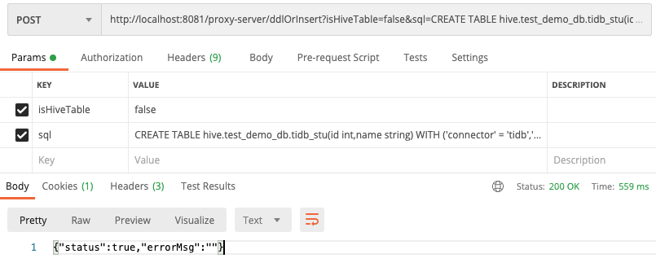

### 5.创建 HIVE 表

http://localhost:8081/proxy-server/ddlOrInsert?isHiveTable=**true**&sql=CREATE TABLE if not exists hive.test_demo_db.hive_city( id int, city string)ROW FORMAT SERDE 'org.apache.hadoop.hive.serde2.lazy.LazySimpleSerDe'WITH SERDEPROPERTIES ( 'field.delim'=',', 'serialization.format'=',')STORED AS INPUTFORMAT 'org.apache.hadoop.mapred.TextInputFormat'OUTPUTFORMAT 'org.apache.hadoop.hive.ql.io.HiveIgnoreKeyTextOutputFormat'

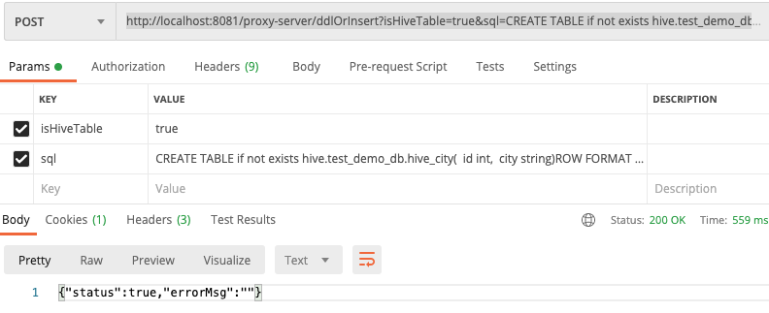

### 6.Hive 表插入测试数据

**分别插入三条数据：**

http://localhost:8081/proxy-server/ddlOrInsert?isHiveTable=true&sql=insert into hive.test_demo_db.hive_city select 0 as id, '北京' as city

http://localhost:8081/proxy-server/ddlOrInsert?isHiveTable=true&sql=insert into hive.test_demo_db.hive_city select 1 as id, '天津' as city

http://localhost:8081/proxy-server/ddlOrInsert?isHiveTable=true&sql=insert into hive.test_demo_db.hive_city select 2 as id, '河北' as city

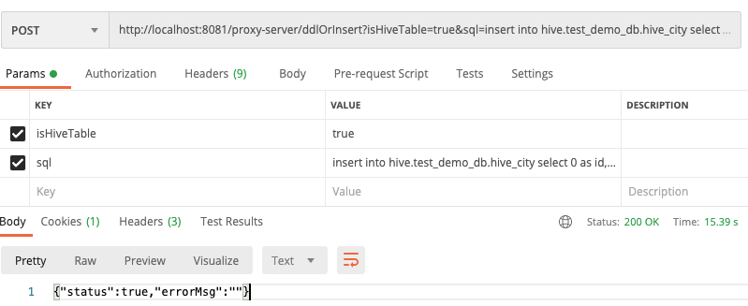

## 7.Join 联合查询

http://localhost:8081/proxy-server/query?sql=select a.id, a.name, b.city from hive.test_demo_db.tidb_stu as a join hive.test_demo_db.hive_city as b on a.id=b.id

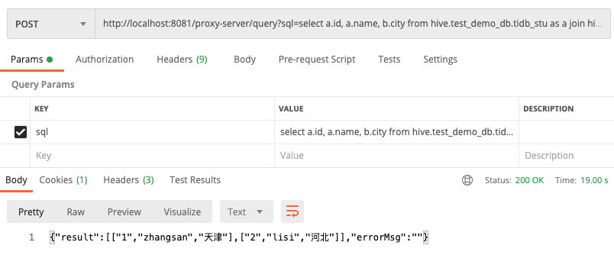

## 8.Join 联合查询结果 insert 到 TIDB

http://localhost:8081/proxy-server/ddlOrInsert?sql=insert into hive.test_demo_db.tidb_stu_details select a.id, a.name, b.city from hive.test_demo_db.tidb_stu as a join hive.test_demo_db.hive_city as b on a.id=b.id

